

DATA STRUCUTRES AND ALGORITHMS
23CSE203
LAB MANUAL

Submitted by

Name | MUTTABATHULA HANSINI SARORA
Roll No | AV.SC.U4CSE25041
Year/Sem/Section | 2nd year/Sem-3/CSE-A
Credits | 05

Submitted to

Name | Dr. RAJ KUMAR BATCHU
Department | School of Computing
Designation | Asst. Professor (SI Grade)

S.NO | TITLE | PAGE NO | REMARKS
1. | WEEK 1: 1a. Recursive countdown from n to Launch.  1b. Recursive calculation of compound growth factor.  1c. Recursive search for employee ID in list.  1d. Recursive factorial calculation for parcel arrangements.  1e. Recursive Fibonacci series generation. | 4 - 12
2. | WEEK 2: 2a. Write a python program to perform linear search on the give input.  2b. Write a python program to perform binary search on the given. Verify by taking sorted array as an input.  2c. Write a python program to perform binary search on the given. Verify by taking unsorted array as an input. | 13 – 19
3. | WEEK 3: 3a. Write a program to perform Bubble Sort technique on the user given input.  3b. Write a program to perform Insertion Sort technique on the user given input.  3c. Write a program to perform Selection Sort technique on the user given input.  3d. Write a program to perform Merge Sort technique on the user given input.  3e. Write a program to perform Quick Sort technique on the user given input. | 20- 31
4. | WEEK 4: Write a python program to implement a single linked list which would perform the below operations, by taking an input from the user.  a. Create a linked list. | 32 - 40
4. | b. Insert at beginning. c. Insert at end.  d. Insert at a specific index.  e. Delete by value. f. Delete 1st node.  g. Delete last node. h. Count no. of nodes i. Display. j. Exit. | 32 - 40

WEEK – 1
1a. AIM: A rocket launch system displays a countdown before launch. Instead of using a loop, implement the countdown using recursive. Write a recursive python program to display a countdown from n to 1, followed by “Launch”.
PROGRAM:
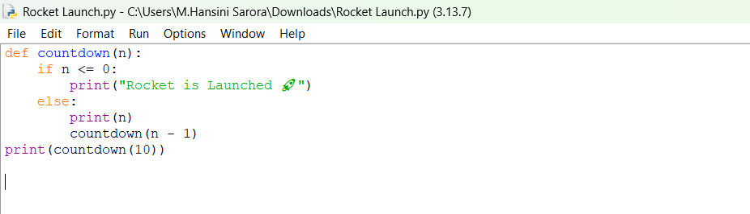

OUTPUT:
Positive Case;
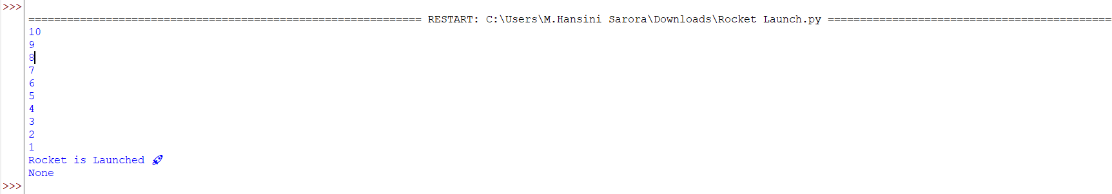
Negative Case;

EXPLANATION:
Condition 1: Positive Input (n > 0)
- The function checks if n <= 0. Since n is positive, this condition is False.
- It executes the else block:
  - Prints the current value of n.
  - Calls itself recursively with n - 1.
- This repeats until n becomes 0.
- Finally, when n = 0, the condition n <= 0 becomes True.
- After the recursive calls finish, the function returns None (since no return is defined).
- The calling print (countdown (10)) will display the countdown, the launch message, and then None.
Condition 2: Negative Input (n <= 0)
- The condition if n <= 0 is immediately True.
- It directly prints:
Rocket is Launched 🚀
- No recursion happens because the else block is skipped.
- The function ends and returns None.
- The calling print (countdown (-1)) will display:
Rocket is Launched 🚀
None
ERROR TABLE:

S.NO | Error Obtained | Rectification
1. | Syntax Error  Forgot to give “:” in the control statement. | Later it was rectified by giving the “:”
2. | Type Error  I have entered a non – integer. | It was rectified by passing only the integers.

1b. AIM: Banks calculate the growth of an investment using compound interest. The formula requires calculating powers, which can be implemented recursively. Write a recursive program to calculate P^{n}(power), Where p = principal growth factor, n = number of years.
PROGRAM:
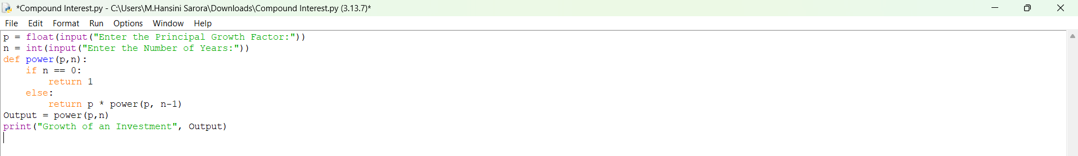

OUTPUT:
Positive Case;
Negative Case; 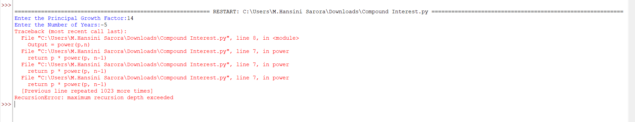

EXPLANATION:
Condition 1: Positive Input (n ≥ 0)
- User enters a positive number of years (e.g., n = 3).
- The function checks if n == 0. Since n is positive, this is False.
- It executes the else block:
  - Multiplies p by the result of power (p, n-1).
- Recursion continues until n becomes 0.
- At n = 0, the base case returns 1.
- The recursive calls unwind, multiplying p repeatedly.
- The output is $p^{n}$, i.e., the growth factor raised to the number of years.
Condition 2: Negative Input (n < 0)
- User enters a negative number of years (e.g., n = -2).
- The function checks if n == 0. Since n is negative, this is False.
- It executes the else block:
  - Calls power (p, n-1) with an even smaller negative number.
- Recursion continues indefinitely (-2 → -3 → -4 → …).
- The base case (n == 0) is never reached.
- Python raises a “Recursion Error: maximum recursion depth exceeded.”
ERROR TABLE:

S.NO | Error Obtained | Rectification
1. | Floating-Point  I have entered a floating-point value in the years. | Later it was rectified by giving the integer value.
2. | Large Input Error  I have given a huge input value. | It was rectified by passing default limit of Python.

1c. AIM: An HR department stores employee IDs in a list. Develop a recursive program to search for a given employee ID. Write a recursive function to search for an employee ID in a list.

PROGRAM:
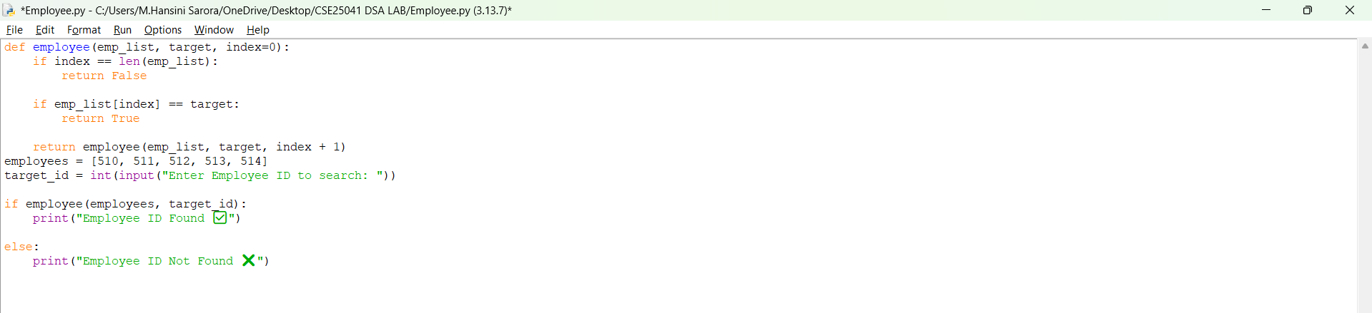

OUTPUT:
Positive Case;
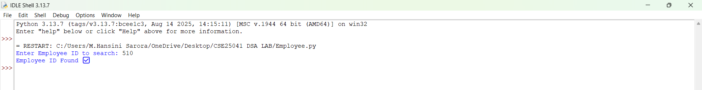
Negative Case; 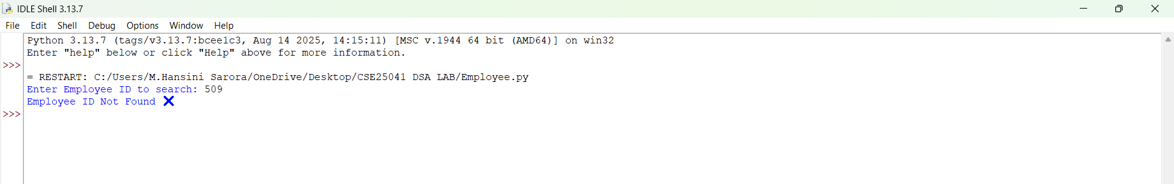

EXPLANATION:
Condition 1: Employee ID Found
- The function starts at index 0.
- It compares emp_list[index] with the target.
- If a match is found, the function immediately returns True.
- The recursion stops early — no need to check further elements.
- The main program prints:
Employee ID Found ✅
Condition 2: Employee ID Not Found
- The function checks each element recursively.
- If the end of the list is reached (index == len(emp_list)), the base case returns False.
- The recursion unwinds, propagating False back to the main program.
- The main program prints:
Employee ID Not Found ❌
ERROR TABLE:

S.NO | Error Obtained | Rectification
1. | Empty List  I haven’t entered the values in the list. | The empty list was filled with the emp IDs.
2. | Logical Error  I have entered the duplicate values. | It was rectified by removing the duplicates.

1d. AIM: In a logistics company, the number of possible ways to arrange n different parcels is calculated using the factorial formula (n!). Develop a recursive program to calculate the factorial of a given number.
PROGRAM:

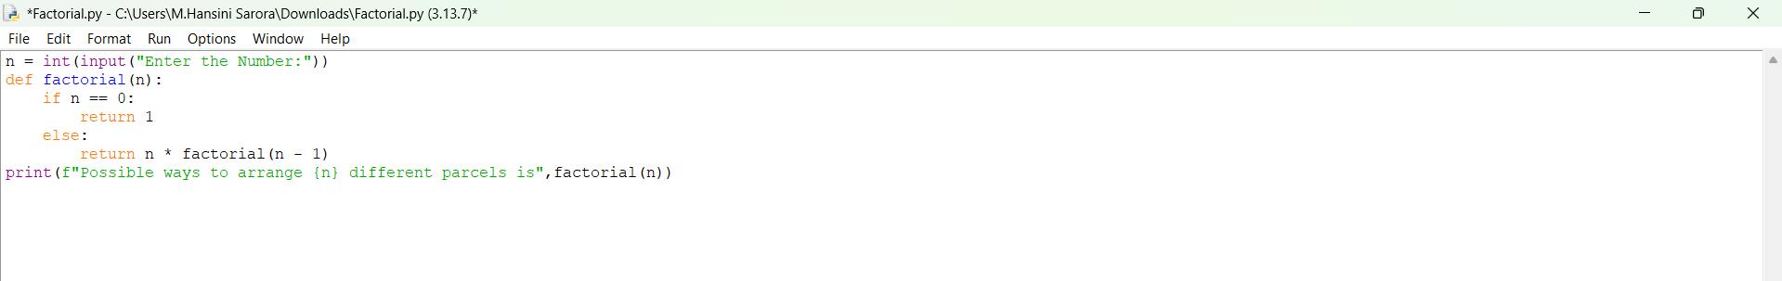

OUTPUT:
Positive Case;
Negative Case; 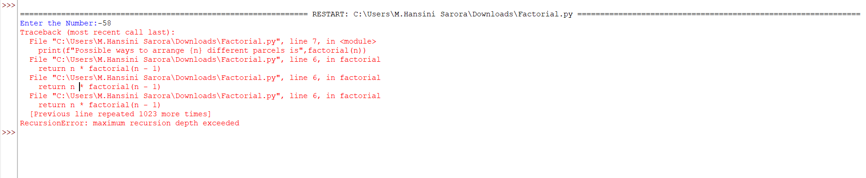

EXPLANATION:
Condition 1: When n == 0
- The function checks:
if n == 0:
return 1
- By definition, $0!=1$.
- So if the user enters 0, the program outputs:
Possible ways to arrange 0 different parcels is 1
Condition 2: When n > 0
- The function executes:
else:
return n * factorial(n - 1)
- This means the function calls itself with a smaller number until it eventually reaches n == 0.
- Uses recursion to multiply numbers down to 1.

ERROR TABLE:

S.NO | Error Obtained | Rectification
1. | Negative Input  I haven’t entered the negative value. | Later, It was rectified by entering positive values.
2. | Large Input Error  I have entered a very large number. | It was rectified by entering limited values.

1e. AIM: Write a recursive python program to print the first n yerms of the Fibonacci Series.
PROGRAM:
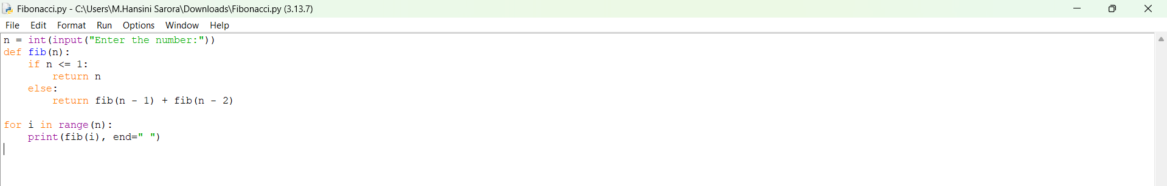

OUTPUT:
Positive Case;
Negative Case;

EXPLANATION:
Condition 1: When n <= 1

- Inside the function:
if n <= 1:
return n
- This is the base case of recursion.
- If n = 0, it returns 0.
- If n = 1, it returns 1.
- These are the starting points of the Fibonacci sequence..
Condition 2: When n > 1
- The function executes:
python
else:
return fib(n - 1) + fib(n - 2)
- This means the Fibonacci number at position n is the sum of the two previous numbers.
- The recursion keeps breaking down until it reaches the base case (n <= 1).
ERROR TABLE:

S.NO | Error Obtained | Rectification
1. | Negative Input  I haven’t entered the negative value. | Later, it was rectified by entering positive values.
2. | Very large input  Recursion depth exceeded. | It was rectified by entering limited values.

WEEK – 2
2a. AIM: Write a python program to perform linear search on the give input.
PROGRAM:
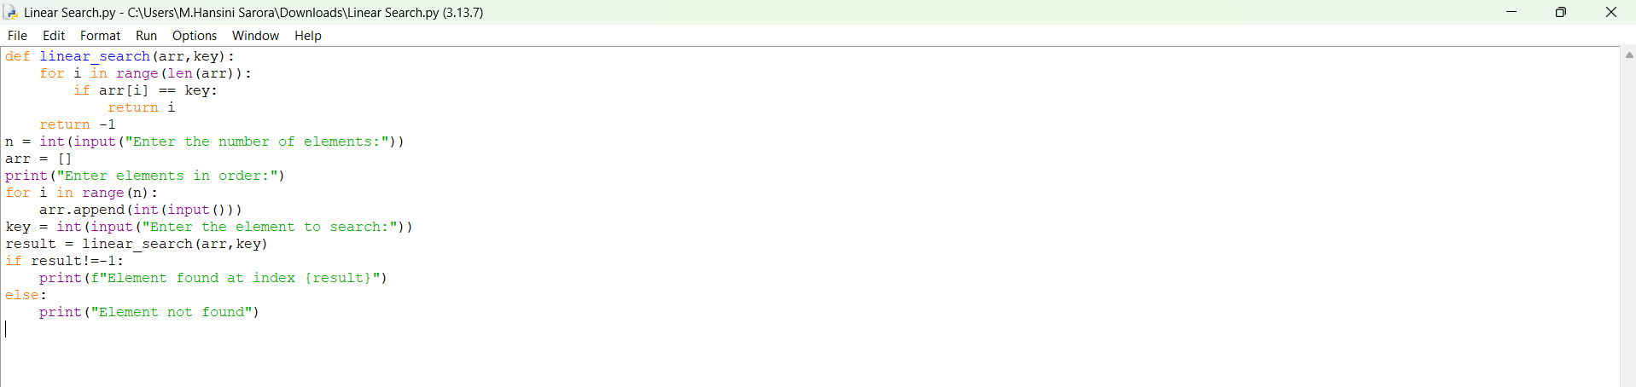

OUTPUT:
Positive Case;
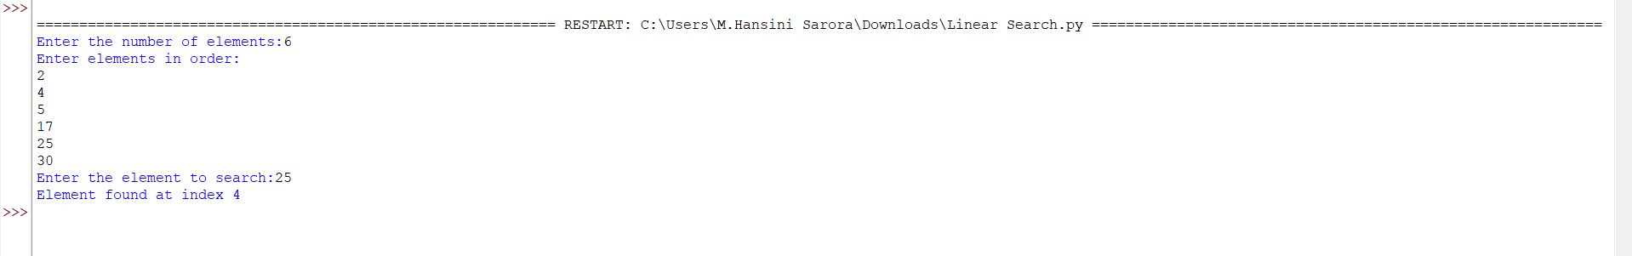
Negative Case;
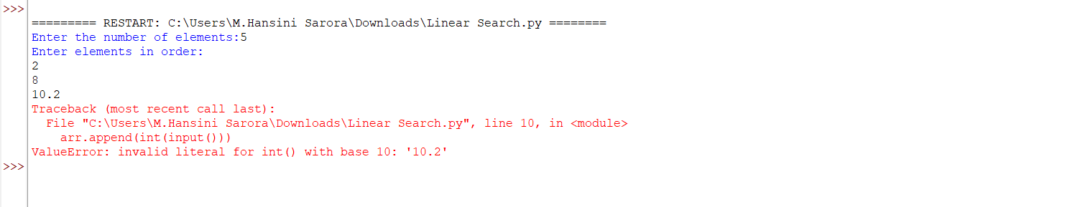

EXPLANATION:
Condition 1: Element Found
- The program takes an array of numbers from the user.
- It then asks for a key (the element to search).
- The linear_search function goes through the array one element at a time.
- If the current element matches the key, the function returns its index.
- In this case, the program prints:
Element found at index <position>
Example:
- Input array: [10, 20, 30, 40]
- Key: 30
- Output: Element found at index 2
Condition 2: Element Not Found
- If the loop finishes and no element matches the key, the function returns -1.
- The program then prints:
Element not found
ERROR TABLE:

S.NO | Error Obtained | Rectification
1. | Indentation error  Return -1 was typed inside the if loop condition. | Later, it was rectified by typing it outside the if loop and inside the for loop.
2. | Syntax error  Invalid syntax,  ! == -1 | It was rectified by re-typing,  ! = -1.

2b. AIM: Write a python program to perform binary search on the given. Verify by taking sorted array as an input.

PROGRAM:
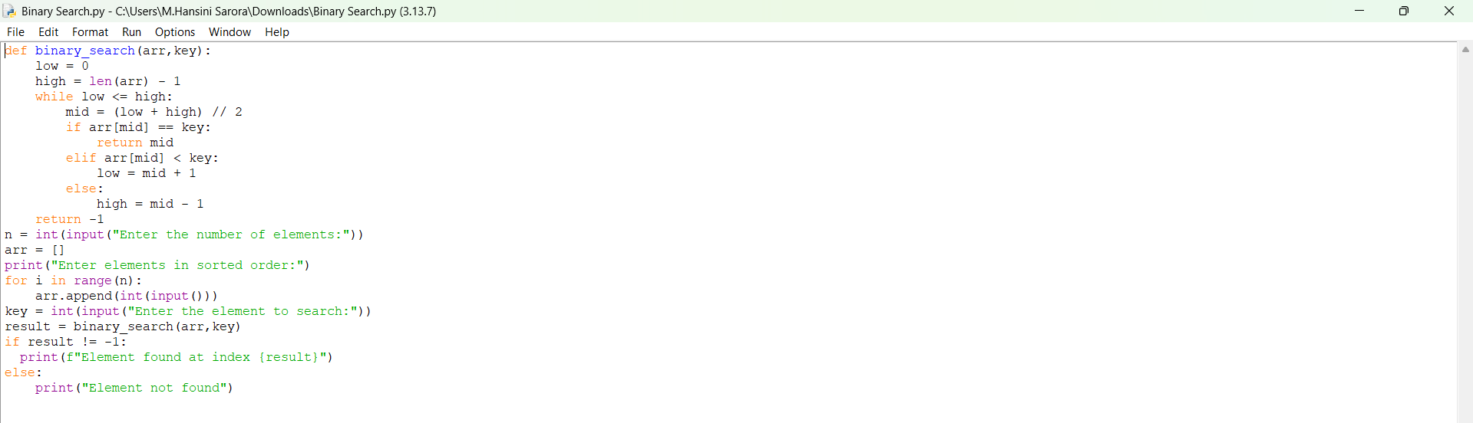

OUTPUT:
Positive Case;
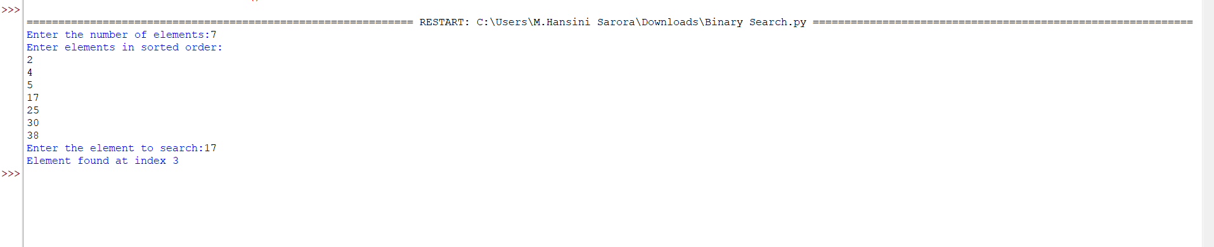
Negative Case;
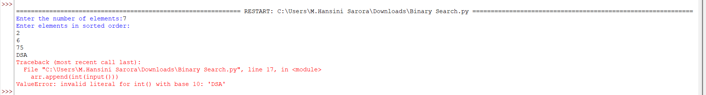

EXPLANATION:
Condition 1: Element Found
- The program asks the user to enter elements in sorted order (binary search only works on sorted arrays).
- The binary_search function starts with two pointers:
- low → beginning of the array
- high → end of the array
- It calculates the middle index mid = (low + high) // 2.
- If the middle element equals the key, the function returns that index.
- The program then prints:
Element found at index <position>
Example:
- Input array: [5, 10, 15, 20, 25]
- Key: 20
- Output: Element found at index 3
Condition 2: Element Not Found
- If the key is not equal to the middle element, the algorithm adjusts the search range:
  - If arr[mid] < key, search continues in the right half (low = mid + 1).
  - If arr[mid] > key, search continues in the left half (high = mid - 1).
- This process repeats until low > high.
- If the key is not found, the function returns -1.
- The program then prints:
Element not found
Example:
- Input array: [5, 10, 15, 20, 25]
- Key: 30
- Output: Element not found

ERROR TABLE:

S.NO | Error Obtained | Rectification
1. | Incorrect loop condition  low < high | Later, it was rectified by writing as  low <= high.
2. | Wrong middle calculation  mid = (low + high) / 2 | It was rectified by re-typing,  mid = (low + high) // 2.

2c. AIM: Write a python program to perform binary search on the given. Verify by taking unsorted array as an input.
PROGRAM:
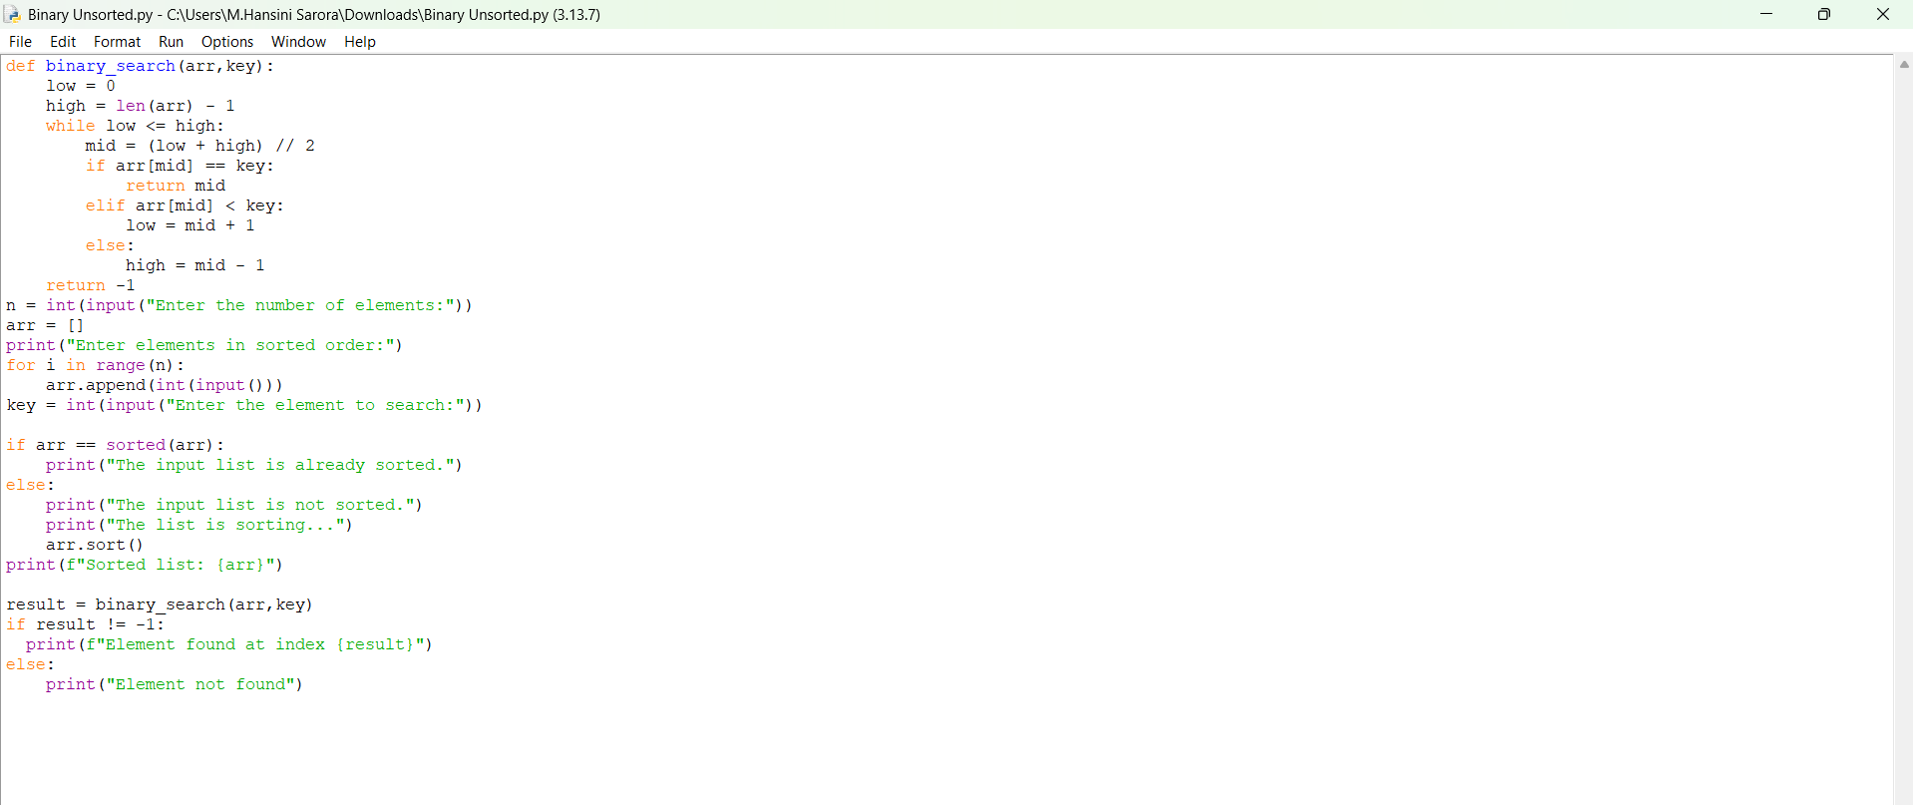

OUTPUT:
Positive Case;
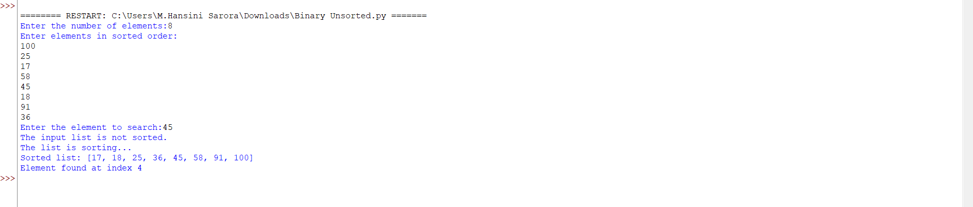
Negative Case;
A semantic error occurs in this case,

EXPLANATION:
Condition 1: Input List Already Sorted
- The program first checks if the entered list is already sorted or not.
- If true, it prints:
The input list is already sorted.
- Then it directly applies binary search on the given list.
- If the key is found, it prints the index:
Element found at index <position>
- Otherwise, it prints:
Element not found
Example:
- Input array: [5, 10, 15, 20]
- Key: 15
- Output:
The input list is already sorted.
Sorted list: [5, 10, 15, 20]
Element found at index 2
Condition 2: Input List Not Sorted
- If the entered list is not sorted, the program prints
The input list is not sorted.
The list is sorting...
- It then sorts the list using:
arr.sort()
- After sorting, it prints the sorted list and applies binary search.
- If the key is found, it prints the index in the sorted list.
- Otherwise, it prints:
Element not found
Example:
- Input array: [20, 5, 15, 10]
- Key: 10
- Output:
The input list is not sorted.
The list is sorting...
Sorted list: [5, 10, 15, 20]
Element found at index 1

ERROR TABLE:

S.NO | Error Obtained | Rectification
1. | Duplicate elements  It does not guarantee the 1st or last occurrence | Later, it was rectified by not entering the duplicate values.
2. | Semantic error  Given an empty list | It was rectified by entering the values in the list.

WEEK – 3
3a. AIM: Write a program to perform Bubble Sort technique on the user given input.
PROGRAM:
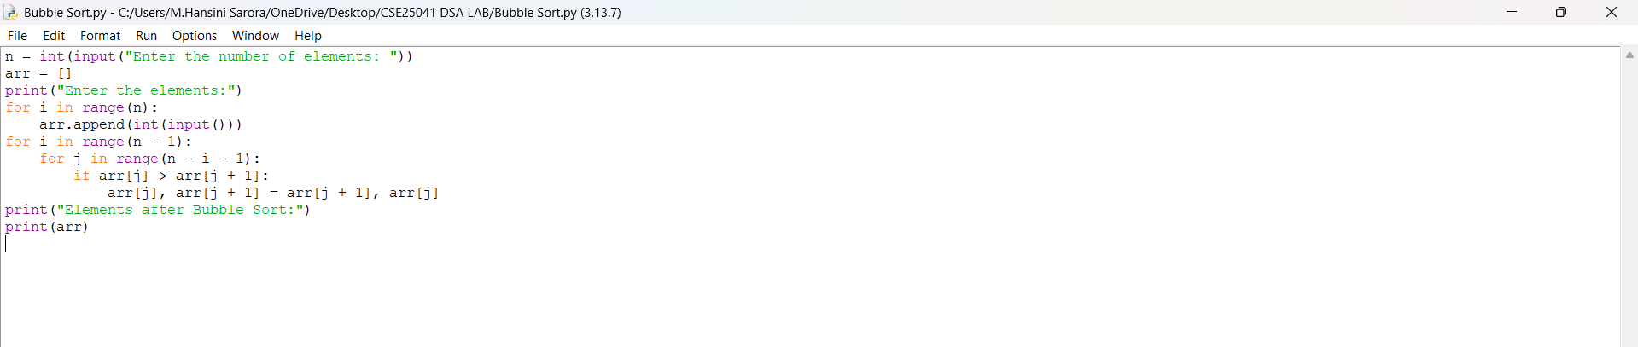

OUTPUT:
Positive Case;
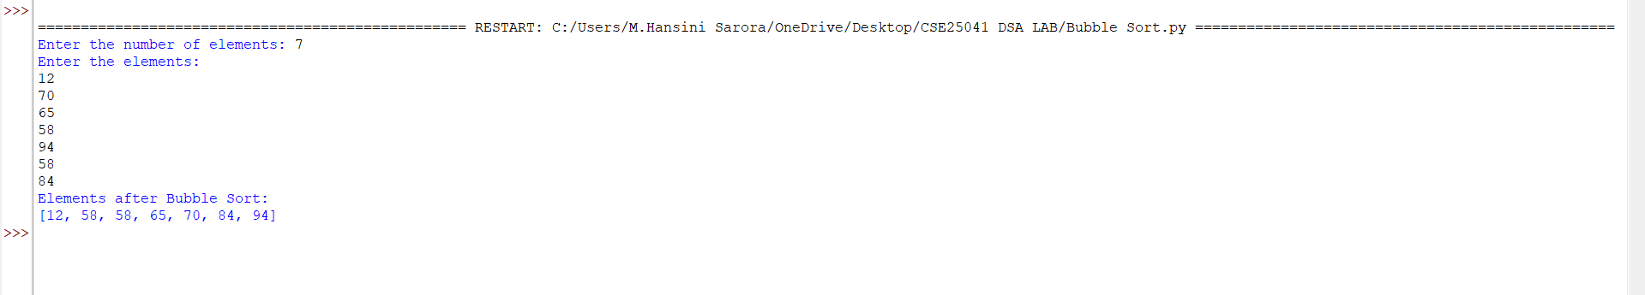
Negative Case;
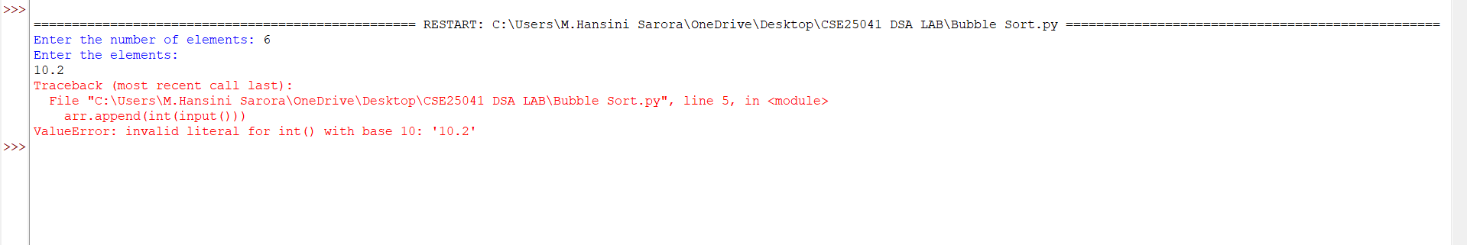

EXPLANATION:
1. Start by taking input size,
The program first asks how many elements (n) the user wants to sort. This sets the boundary for loops.
2. Input the elements into the list,
The user enters n numbers, which are stored in the list arr.
3. Begin Bubble Sort process,
Sorting starts with two nested loops:
- Outer loop (i) → Controls the number of passes. Runs n-1 times because after each pass one element is placed correctly at the end.
- Inner loop (j) → Compares adjacent elements in each pass.
4. Condition check inside inner loop,
- The condition is: if the current element is greater than the next element (arr[j] > arr[j+1]).
- If this condition is true, the two elements are swapped.
- If the condition is false, no swap is made and the loop continues.
5. Effect of condition and swapping,
- Each time the condition is true, larger elements move step by step toward the end of the list.
- After the first pass, the largest element is at the last position.
- After the second pass, the second-largest is in its correct position, and so on.
6. Completion of sorting,
When all passes are finished, the list is sorted in ascending order. The program then prints the sorted list.

ERROR TABLE:

S.NO | Error Obtained | Rectification
1. | Logical Error  if arr[j] > arr[j + 1]: | It will sort in descending order, so it was rectified by changing it to “<” this.
2. | Semantic error  Given an empty list | It was rectified by entering the values in the list.
3b. AIM: Write a program to perform Insertion Sort technique on the user given input.
PROGRAM:
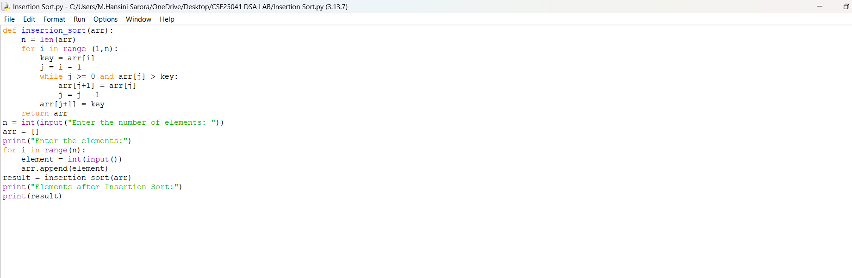

OUTPUT:
Positive Case;
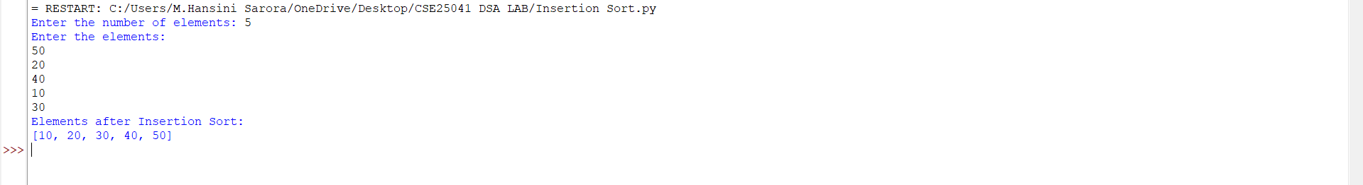
Negative Case;
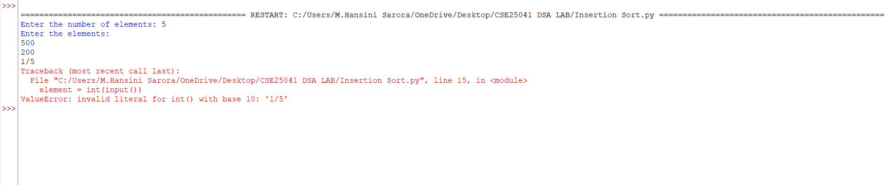

EXPLANATION:
1. Input Phase,
- The program first asks the user for the number of elements (n).
- Then it takes n integer inputs one by one and stores them in the list arr.
2. Insertion Sort Process,
Insertion Sort works by building the sorted list one element at a time:
- Outer loop (i from 1 to n-1): Starts from the second element because the first element is trivially sorted. Each iteration picks the current element (key) and tries to place it in the correct position among the already sorted part of the list.
- Condition check inside while loop:
  - The condition is: while j >= 0 and arr[j] > key
  - Meaning: As long as the previous element (arr[j]) is greater than the current element (key), shift it one position to the right.
  - If the condition is true, shifting happens.
  - If the condition is false, the correct position for key is found.
- Placement of key: After shifting larger elements, the key is placed at its correct position (arr[j+1] = key).
3. Output Phase,
- After all passes, the list is fully sorted in ascending order.
- The program prints the sorted list.

ERROR TABLE:

S.NO | Error Obtained | Rectification
1. | Syntax error | Later, it was rectified by typing it as ‘:’ in loop.
2. | Condition check  j <= 0 | It was rectified by correcting it with ‘>’.  It could cause negative indexing errors.
3c. AIM: Write a program to perform Selection Sort technique on the user given input.
PROGRAM:
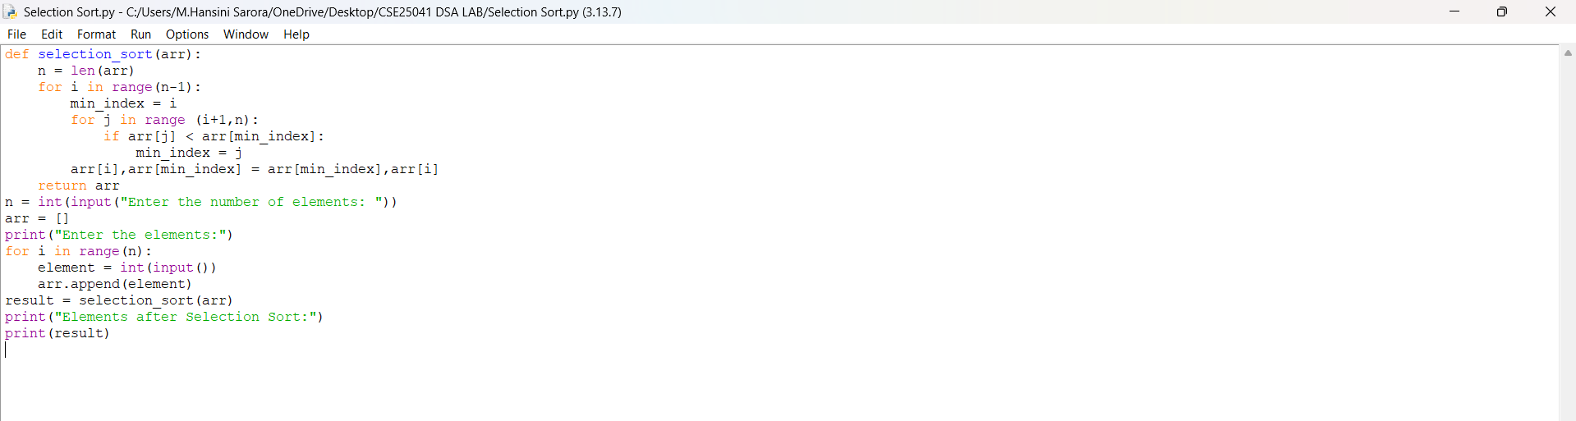
OUTPUT:
Positive Case;
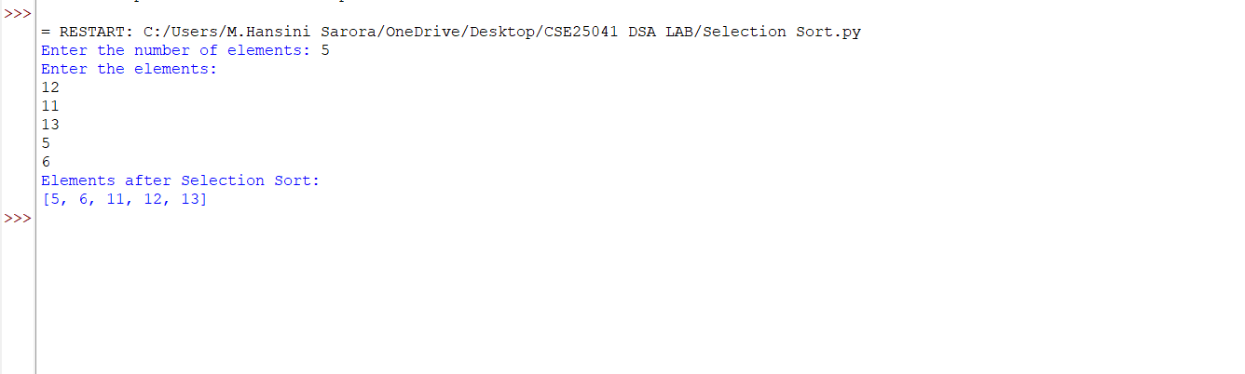
Negative Case;
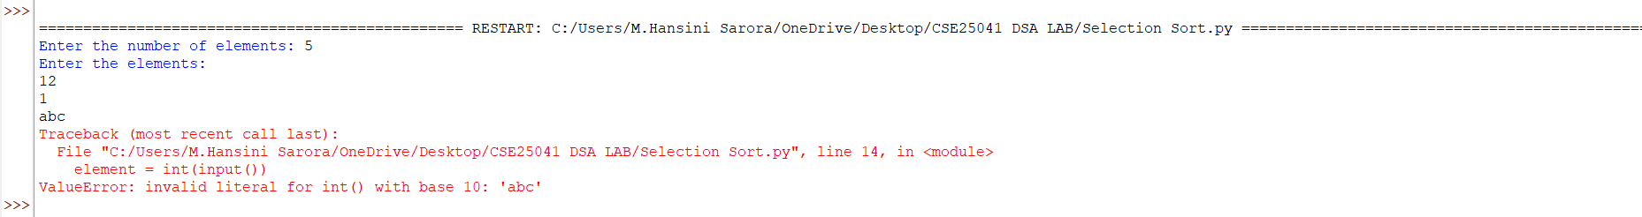
EXPLANATION:
1. Input Phase
- The program first asks the user for the number of elements (n).
- Then it takes n integer inputs one by one and stores them in the list arr.

2. Selection Sort Process
Selection Sort works by repeatedly finding the smallest element from the unsorted part of the list and placing it at the beginning.
- Outer loop (i from 0 to n-2): Each iteration selects the position where the next smallest element should be placed.
- Initialize minimum index: At the start of each pass, min_index = i. This assumes the current element is the smallest.
- Inner loop (j from i+1 to n-1): Compares the current minimum element with the rest of the unsorted elements.
  - Condition check: if arr[j] < arr[min_index]
    - If true, update min_index = j (a new smaller element is found).
    - If false, keep the current min_index.
    - Swap after inner loop: After checking all elements, swap the smallest element found (arr[min_index]) with the element at position i. This places the correct element in its sorted position.
3. Output Phase
- After all passes, the list is fully sorted in ascending order.
- The program prints the sorted list.

ERROR TABLE:

S.NO | Error Obtained | Rectification
1. | Syntax error | Later, it was rectified by typing it as ‘:’ in loop.
2. | Meaningless behaviour when n = 0 or negative | Add a condition: if n <= 0, print "No elements to sort" and skip sorting.
3d. AIM: Write a program to perform Merge Sort technique on the user given input.
PROGRAM:
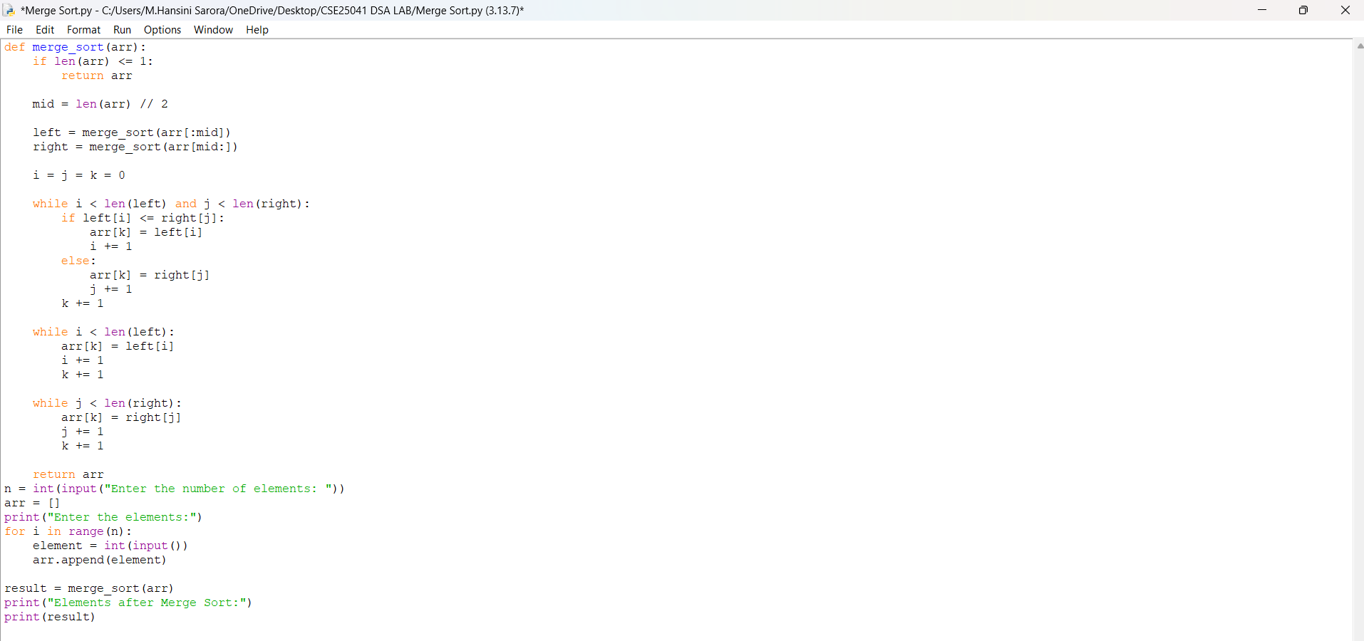

OUTPUT:
Positive Case;
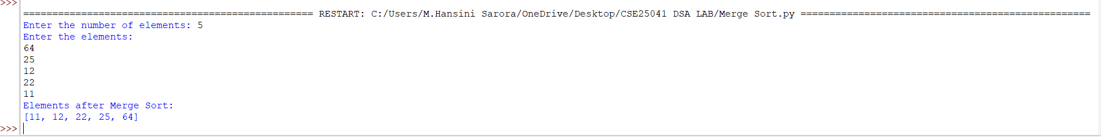
Negative Case;
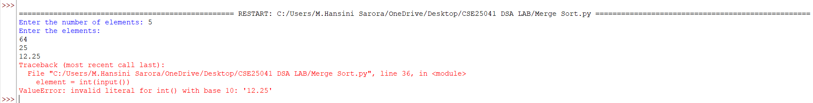

EXPLANATION:
Step 1: Input Phase
- The program first asks the user for the number of elements (n).
- Then it takes n integer inputs one by one and stores them in the list arr.
Step 2: Merge Sort Process
Merge Sort is a divide and conquer algorithm. It divides the list into smaller parts, sorts them individually, and then merges them back together.
Condition 1: Base Case
- If the list has one or zero elements, it is already sorted.
  - Condition: if len(arr) <= 1:
  - Action: Return the list as it is.
Condition 2: Divide Step
- Find the middle index: mid = len(arr) // 2
- Split the list into two halves:
  - Left half → arr[:mid]
  - Right half → arr[mid:]
- Recursively call merge_sort() on both halves:
  - left = merge_sort(arr[:mid])
  - right = merge_sort(arrr[mid:])
Step 3: Merge Step
After both halves are sorted, they are merged together in ascending order.
Condition 3: Comparing elements
- Initialize three counters: i, j, and k to 0.
- While both halves have elements left:
  - Condition: while i < len(left) and j < len(right):
  - Compare elements:
    - If left[i] <= right[j] → place left[i] in the merged list.
    - Else → place right[j] in the merged list.
  - Increment counters accordingly.
Condition 4: Copy remaining elements
- If one half finishes early, copy the remaining elements from the other half.
  - Condition: while i < len(left): → copy remaining left elements.
  - Condition: while j < len(right): → copy remaining right elements.
Step 4: Return Sorted List
- After merging, return the sorted list to the previous recursive call.
- Finally, print the sorted list after all recursive merges are complete.

ERROR TABLE:

S.NO | Error Obtained | Rectification
1. | Index error  List index out of range | Later, it was rectified by few corrections in while loop.
2. | Syntax error | Later, it was rectified by typing it as ‘:’ in loop.

3e. AIM: Write a program to perform Merge Sort technique on the user given input.

PROGRAM:
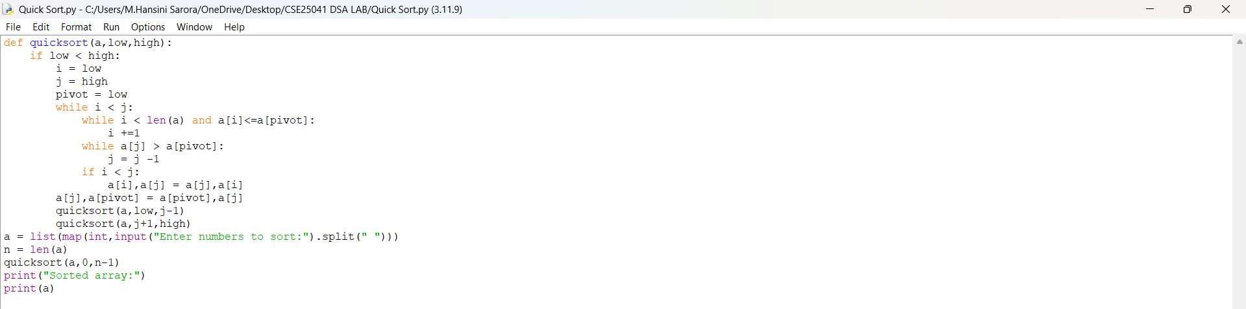
OUTPUT:
Positive Case;
Negative Case;

EXPLANATION:
Step 1: Input Phase
- The program asks the user to enter numbers separated by spaces.
- These numbers are converted into integers and stored in the list a.
- The length of the list (n) is calculated.
Step 2: Quick Sort Function
Quick Sort is a divide and conquer algorithm. It works by choosing a pivot element, partitioning the list around the pivot, and then recursively sorting the partitions.
Condition 1: Base Case
- The function runs only if low < high.
- If this condition is false (meaning the sublist has one or zero elements), the recursion stops because the list is already sorted.
Condition 2: Partitioning
- Variables i = low, j = high, and pivot = low are initialized.
- The pivot is chosen as the first element of the sublist.
Inner conditions:
- while i < len(a) and a[i] <= a[pivot]: i += 1
  - Condition checks if the current element is less than or equal to the pivot.
  - If true, move i forward.
  - If false, stop and prepare for a swap.
- while a[j] > a[pivot]: j -= 1
  - Condition checks if the current element is greater than the pivot.
  - If true, move j backward.
  - If false, stop and prepare for a swap.
- Swap condition:
  - If i < j, swap a[i] and a[j].
  - This ensures smaller elements move to the left of the pivot and larger ones to the right.
Condition 3: Pivot Placement
- After partitioning, swap the pivot element with a[j].
- This places the pivot in its correct sorted position.
Step 3: Recursive Calls
- After placing the pivot, Quick Sort is called recursively on the two partitions:
  - Left sublist: quicksort (a, low, j-1)
  - Right sublist: quicksort (a, j+1, high)
- Each recursive call applies the same conditions until the entire list is sorted.

Step 4: Output Phase
- Finally, the sorted list is printed.

ERROR TABLE:

S.NO | Error Obtained | Rectification
1. | Index Error  When j becomes negative if pivot is very small compared to other elements. | Add boundary check:  while j >= low and a[j] > a[pivot]: j -= 1.
2. | Unnecessary swaps  When i and j point to the same element. | Add condition check before swapping:  only swap if i < j.

WEEK – 4
4. AIM: Write a python program to implement a single linked list which would perform the below operations, by taking an input from the user.
a. Create a linked list. b. Insert at beginning. c. Insert at end.
d. Insert at a specific index. e. Delete by value. f. Delete 1st node.
g. Delete last node. h. Count no. of nodes i. Display.
j. Exit.
PROGRAM:
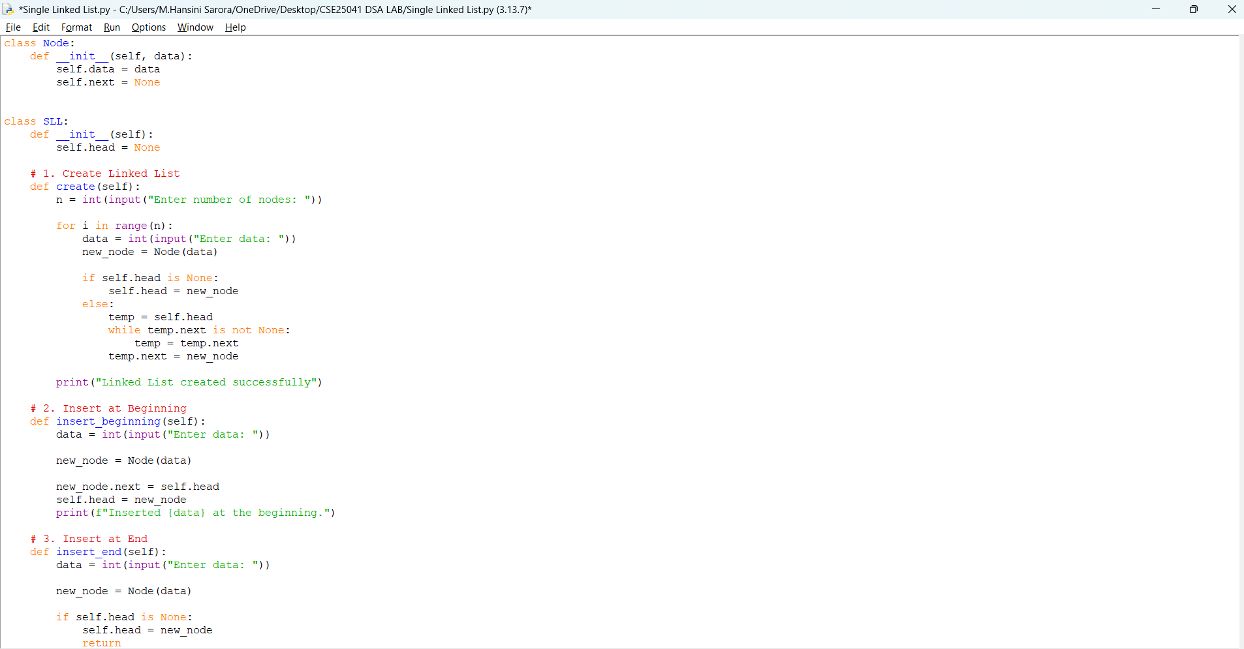
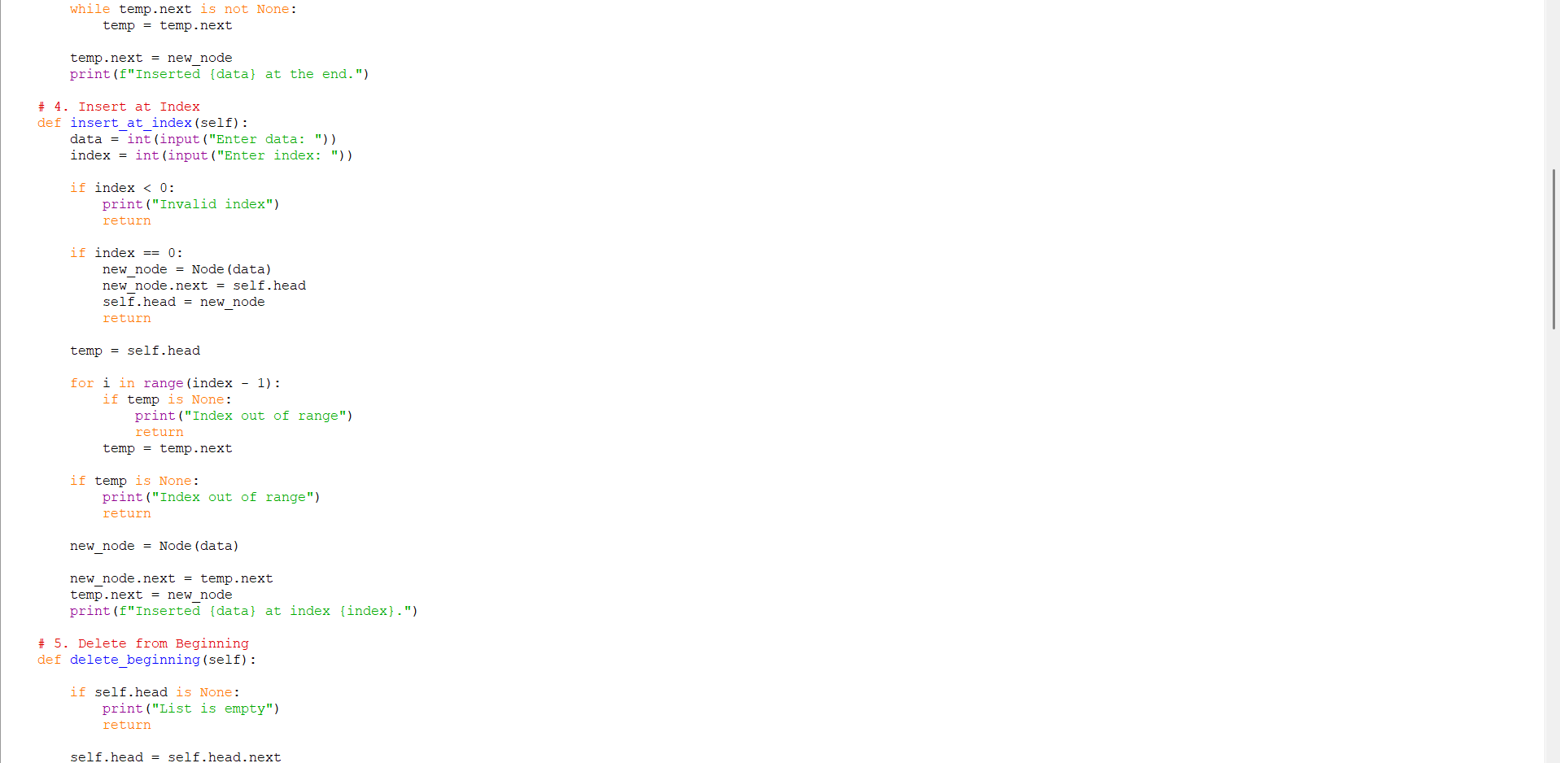
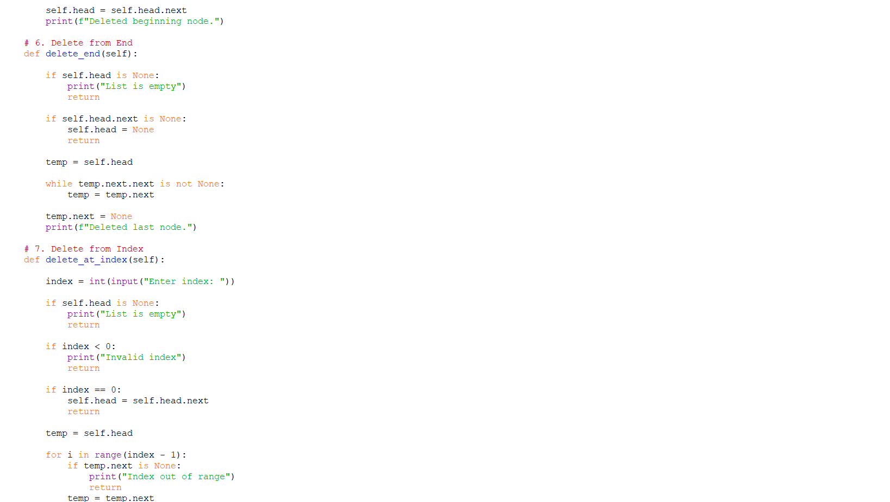
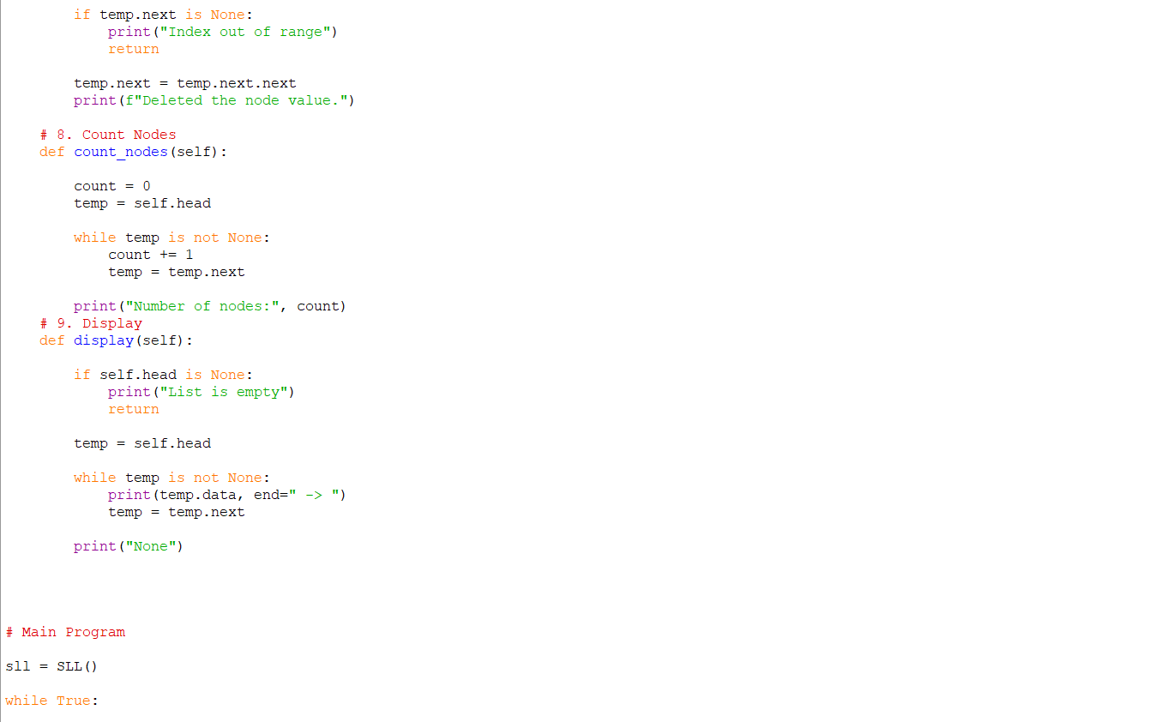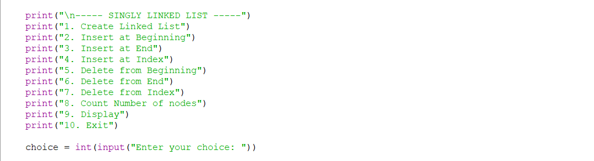

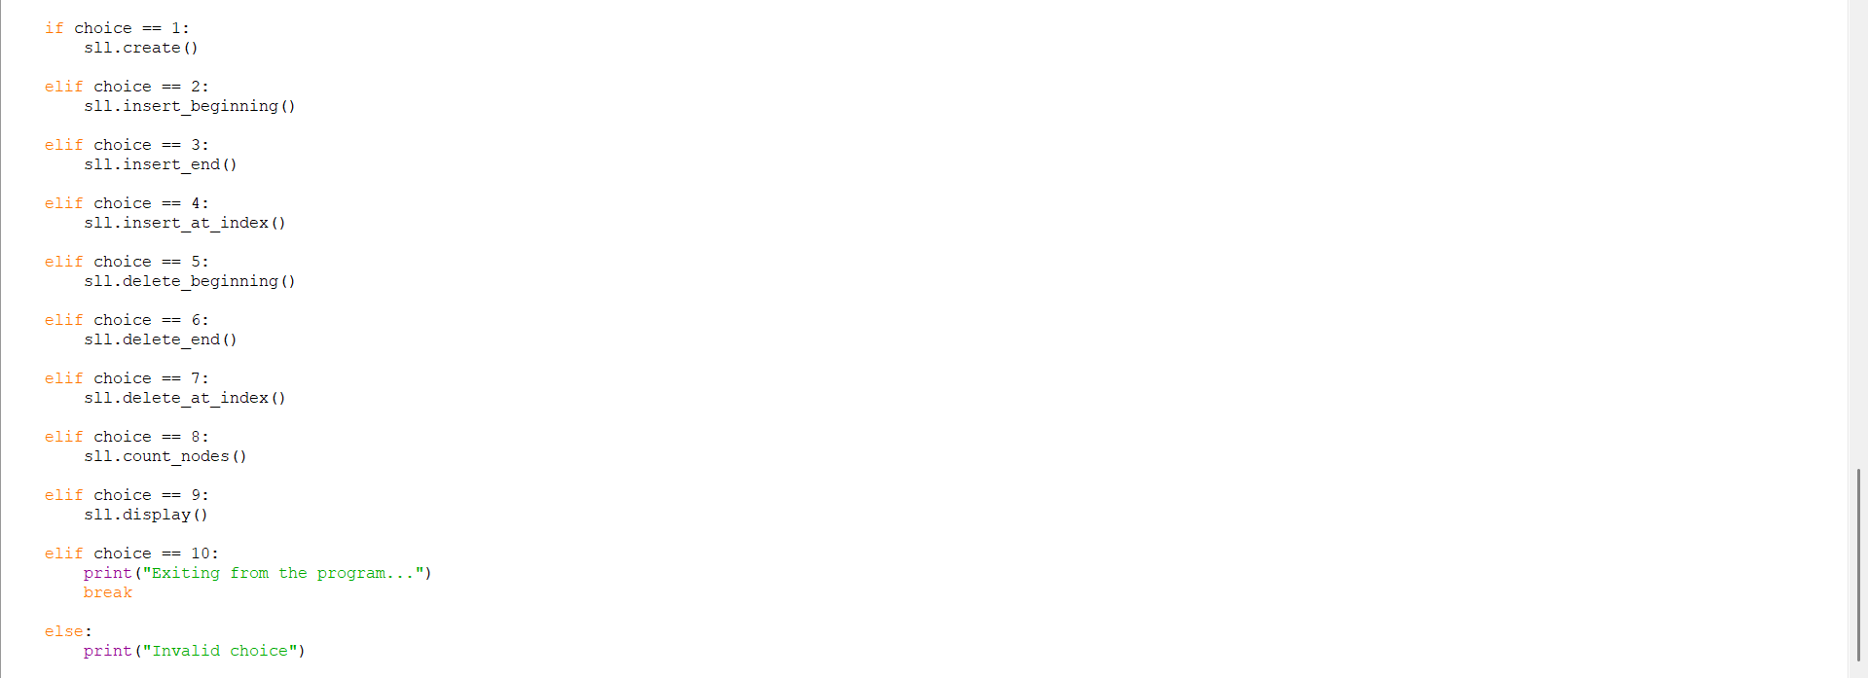

OUTPUT:
Positive Case;
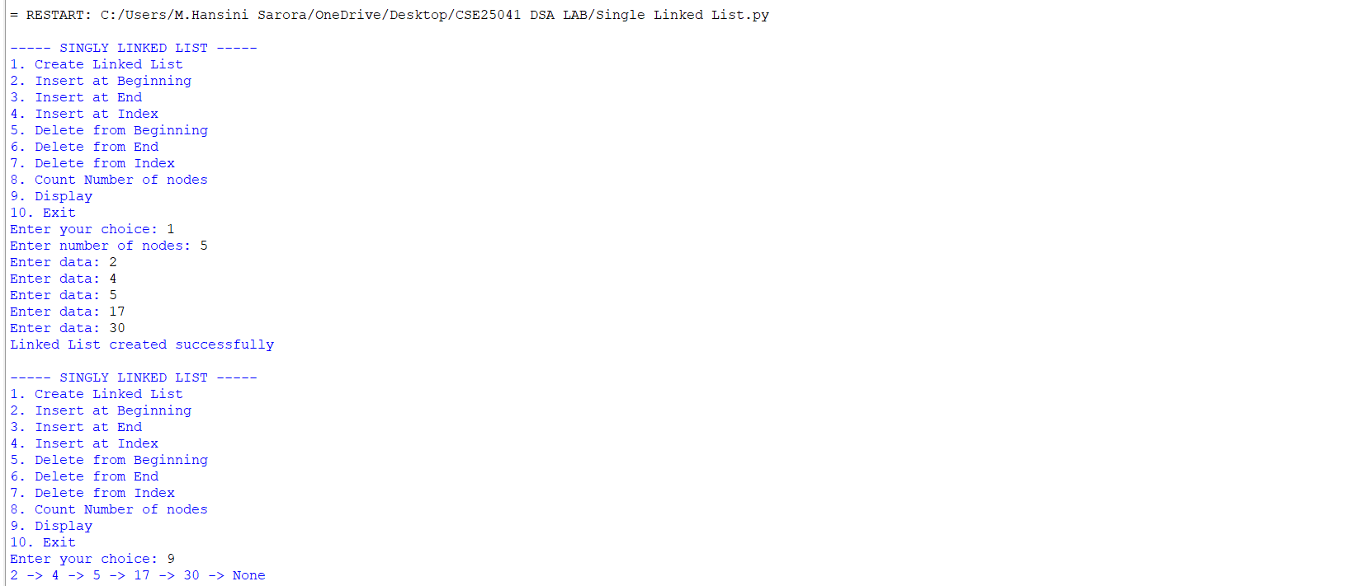
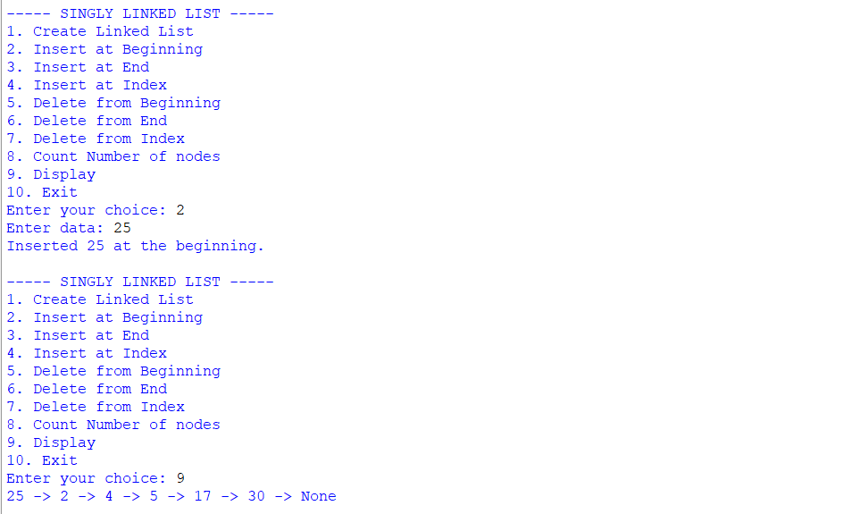
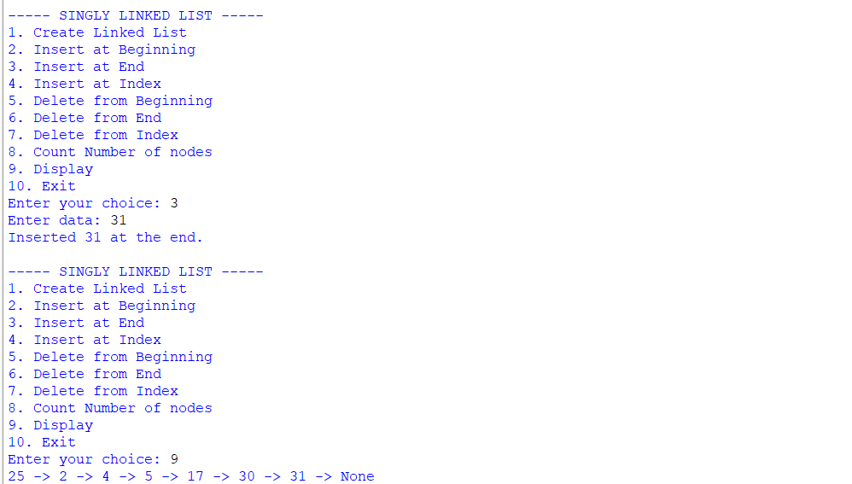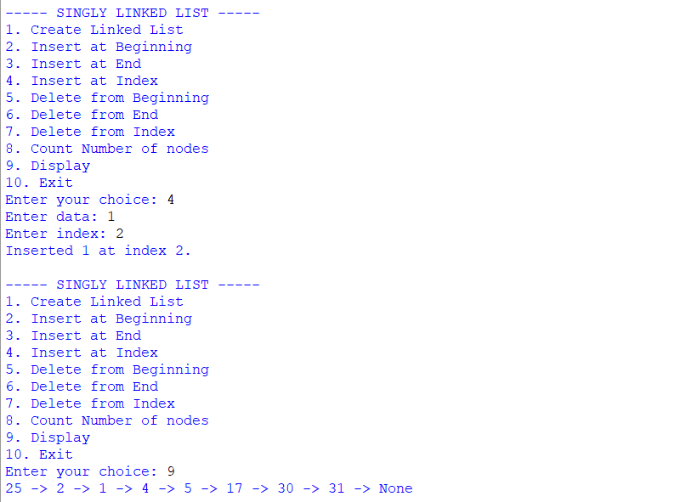

Below is the continution of the output for a program.,

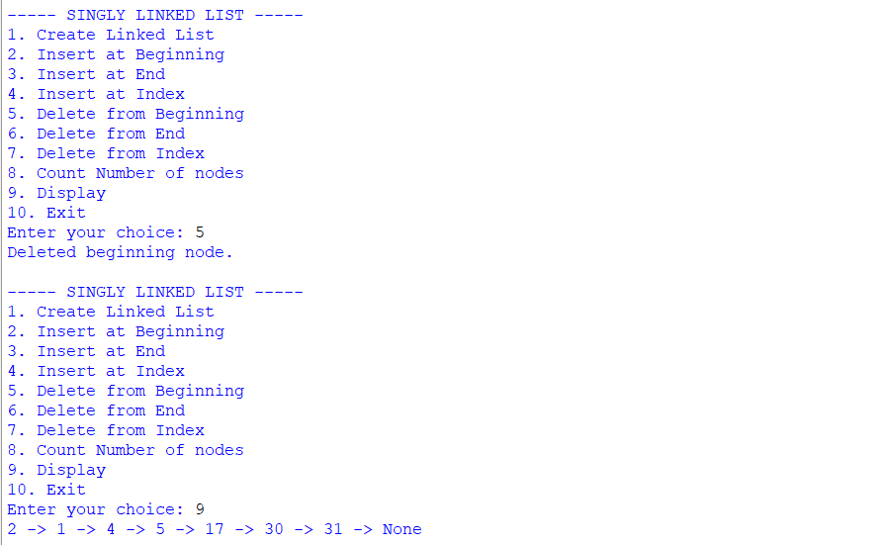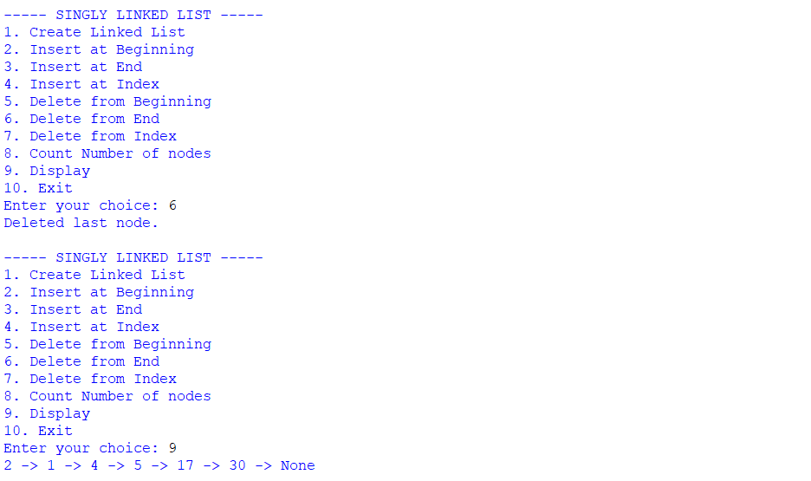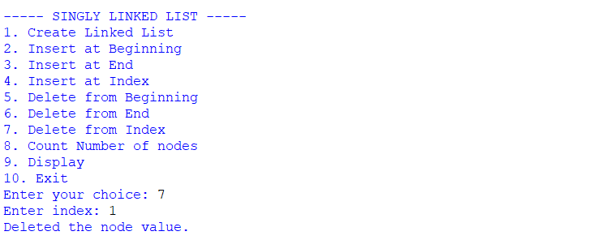
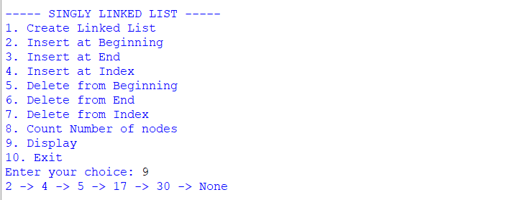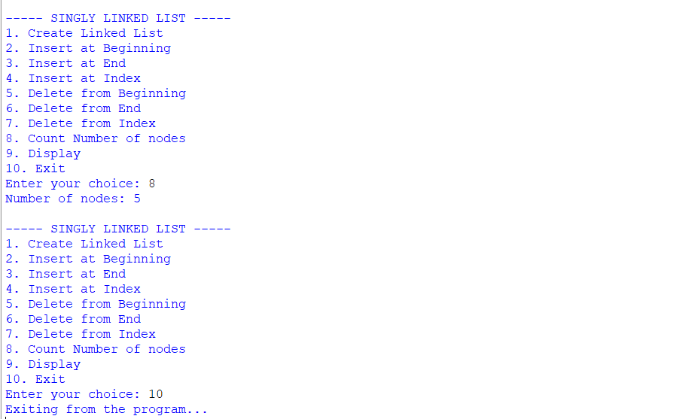
Negative Case;
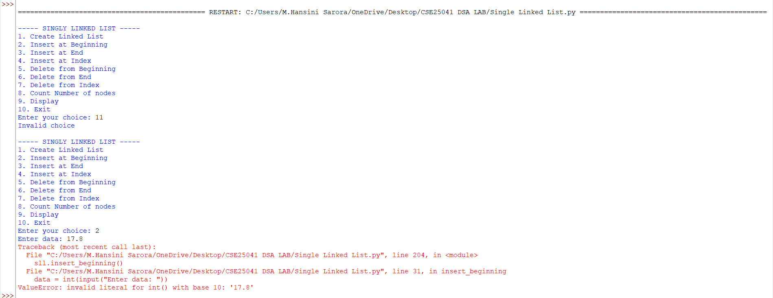

EXPLANATION:
🔹 Class Definitions
- Node class
  - Represents a single node in the linked list.
  - Each node has:
    - data → stores the value.
    - next → pointer to the next node (initially None).
- SLL class
  - Manages the linked list operations.
  - Has a head pointer (initially None) that points to the first node.
🔹 Operations in SLL
1. Create Linked List
- Asks user for number of nodes.
- For each node:
  - Creates a new Node.
  - If list is empty → new node becomes head.
  - Otherwise → traverses to the end and attaches the new node.
2. Insert at Beginning
- Creates a new node.
- Points its next to current head.
- Updates head to new node.
3. Insert at End
- Creates a new node.
- If list is empty → new node becomes head.
- Otherwise → traverses to last node and attaches new node.
4. Insert at Index
- Asks for index and data.
- If index = 0 → behaves like "insert at beginning".
- Otherwise → traverses to (index-1) node and inserts new node in between.
5. Delete from Beginning
- Moves head to head.next.
- Effectively removes the first node.
6. Delete from End
- If list empty → prints "List is empty".
- If only one node → sets head = None.
- Otherwise → traverses to second-last node and sets its next = None.
7. Delete from Index
- Asks for index.
- If index = 0 → removes head.
- Otherwise → traverses to (index-1) node and skips the next node.
8. Count Nodes
- Traverses through list.
- Counts nodes until None.
9. Display
- Traverses from head to end.
- Prints each node’s data in data -> data -> None format.
🔹 Main Program
- Runs an infinite loop with a menu:
  - Options 1–9 → perform linked list operations.
  - Option 10 → exits program.
- Uses if-elif to call respective methods.

ERROR TABLE:

S.NO | Error Obtained | Rectification
1. | Index out of range  When inserting/deleting at an index greater than the number of nodes. | Traverse carefully;  if temp becomes None before reaching index, print "Index out of range" and stop.
2. | Logical error in insertion  if index is negative. | Validate index: if index < 0: print ("Invalid index").
3. | Wrong output format  In display (missing None at end). | After traversal, always print "None" to mark end of list.
4. | Indentation Error  In the Count node part | It was rectified later,  By maintaining proper indentation.

